

**Green University of Bangladesh**

**Department of Computer Science and Engineering (CSE)**

**Faculty of Sciences and Engineering**

**Semester: (Spring, Year:2021), B.Sc. in CSE (Day/Eve)**

**Course Title: Data Structure Lab**

**Course Code: CSE 106 Section: DC**

**Lab Project Name: Bank Management System**

**Student Details**

| **Name** | | **ID** |
| --- | --- | --- |
| **1.** | Shanjida Akter Shochona | 213902093 |

**Submission Date : 11 September 2022**

**Course Teacher’s Name : Md. Sultanul Islam Ovi**

**[For Teachers use only: Don’t Write Anything inside this box]**

| **Lab Project Status**  **Marks: ………………………………… Signature: .....................**  **Comments: .............................................. Date: ..............................** |
| --- |

Table of Contents

**Chapter 1 Introduction 3**

1.1 Introduction 3

1.2 Design Goals/Objective 3

**Chapter 2 Implementation of the Project 4**

2.1 Flow Charts

2.2 Implementation 4

2.3. SreenShots of Output 4

**Conclusion 6**

3.1 Introduction 6

3.2 Practical Implications 6

3.3 Scope of Future Work 6

**References 7**

# Chapter 1 Introduction

## Introduction

## **F**irst of all we should know about C Program how to come and what is the history.C is one of the high-level programming languages developed by Dennis Ritchie. C was originally developed for UNIX operating system to beat the issues of previous languages such as B, BCPL, etc. The UNIX operating system development started in the year 1969, and its code was rewritten in C in the year 1972.

We make Bank Management System using C Language. You may use this [C Language](https://www.studytonight.com/c/)  Project to establish a

Create new account.

Change existing account information.

See and manage transactions.

Verify the details of an existing account.

Delete an existing account.

Browse a list of customers.

Overall, this project allows you to do financial transactions as if you were at a real bank. A console program without graphics is a part of the bank management mini project in C Language.

## Design Goals/Objective

.

The main aim of designing and developing this Internet banking System C language primarily based . Engineering project is to provide secure and efficient net banking facilities to the banking customers over the internet. Apache Server Pages, database used to develop this bank application where all banking customers can login through the secured web page by their account login id and password. Users will have all options and features in that application like get money from western union, money transfer to others, and send cash or money to inter banking as well as other banking customers by simply adding them as payees. C language is common and first language in the world that is most easy language so that I use that . When we compleate our program then you can easily create account in any bank with high sequraty because our c language is high sequre programming Language. User can easily login and do every things with there real account any place and any where.

# Chapter 2

# Implementation of the Project

## Flow Chart

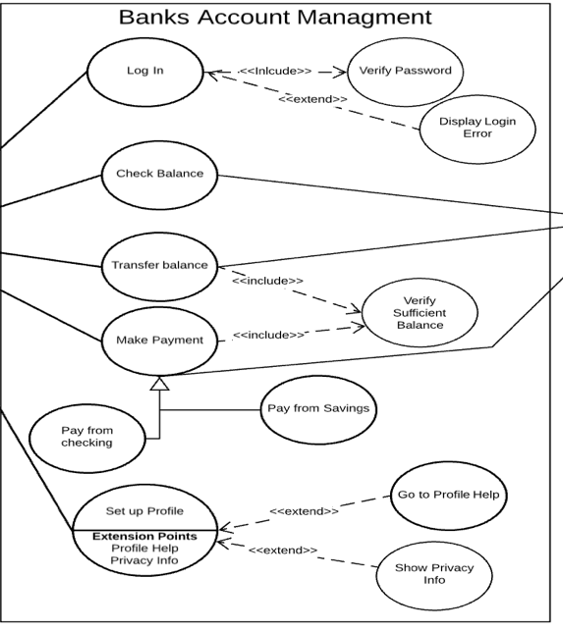

* 1. **Implementation**

**#include<stdio.h>**

**#include<stdlib.h>**

**#include<windows.h>**

**int i,j;**

**int main_exit;**

**void menu();**

**struct date{**

**int month,day,year;**

**};**

**struct {**

**char name[60];**

**int acc_no,age;**

**char address[60];**

**char NID[15];**

**double phone;**

**char acc_type[10];**

**float amt;**

**struct date dob;**

**struct date deposit;**

**struct date withdraw;**

**}add,upd,check,rem,transaction;**

**float interest(float t,float amount,int rate)**

**{**

**float SI;**

**SI=(rate*t*amount)/100.0;**

**return (SI);**

**}**

**void fordelay(int j)**

**{ int i,k;**

**for(i=0;i<j;i++)**

**k=i;**

**}**

**void new_acc()**

**{**

**int choice;**

**FILE *ptr;**

**ptr=fopen("record.dat","a+");**

**account_no:**

**system("cls");**

**printf("\t\t\t ADD RECORD ");**

**printf("\n\n\nEnter today's date(mm/dd/yyyy):");**

**scanf("%d/%d/%d",&add.deposit.month,&add.deposit.day,&add.deposit.year);**

**printf("\nEnter the account number:");**

**scanf("%d",&check.acc_no);**

**while(fscanf(ptr,"%d %s %d/%d/%d %d %s %s %lf %s %f %d/%d/%d\n",&add.acc_no,add.name,&add.dob.month,&add.dob.day,&add.dob.year,&add.age,add.address,add.NID,&add.phone,add.acc_type,&add.amt,&add.deposit.month,&add.deposit.day,&add.deposit.year)!=EOF)**

**{**

**if (check.acc_no==add.acc_no)**

**{printf("Account no. already in use!");**

**fordelay(1000000000);**

**goto account_no;**

**}**

**}**

**add.acc_no=check.acc_no;**

**printf("\nEnter the name:");**

**scanf("%s",add.name);**

**printf("\nEnter the date of birth(mm/dd/yyyy):");**

**scanf("%d/%d/%d",&add.dob.month,&add.dob.day,&add.dob.year);**

**printf("\nEnter the age:");**

**scanf("%d",&add.age);**

**printf("\nEnter the address:");**

**scanf("%s",add.address);**

**printf("\nEnter the NID number:");**

**scanf("%s",add.NID);**

**printf("\nEnter the phone number: ");**

**scanf("%lf",&add.phone);**

**printf("\nEnter the amount to deposit:$");**

**scanf("%f",&add.amt);**

**printf("\nType of account:\n\t#Saving\n\t#Current\n\t#Fixed1(for 1 year)\n\t#Fixed2(for 2 years)\n\t#Fixed3(for 3 years)\n\n\tEnter your choice:");**

**scanf("%s",add.acc_type);**

**fprintf(ptr,"%d %s %d/%d/%d %d %s %s %lf %s %f %d/%d/%d\n",add.acc_no,add.name,add.dob.month,add.dob.day,add.dob.year,add.age,add.address,add.NID,add.phone,add.acc_type,add.amt,add.deposit.month,add.deposit.day,add.deposit.year);**

**fclose(ptr);**

**printf("\nAccount created successfully!");**

**add_invalid:**

**printf("\n\n\n\t\tEnter 1 to go to the main menu and 0 to exit:");**

**scanf("%d",&main_exit);**

**system("cls");**

**if (main_exit==1)**

**menu();**

**else if(main_exit==0)**

**close();**

**else**

**{**

**printf("\nInvalid!\a");**

**goto add_invalid;**

**}**

**}**

**void view_list()**

**{**

**FILE *view;**

**view=fopen("record.dat","r");**

**int test=0;**

**system("cls");**

**printf("\nACC. NO.\tNAME\t\t\tADDRESS\t\t\tPHONE\n");**

**while(fscanf(view,"%d %s %d/%d/%d %d %s %s %lf %s %f %d/%d/%d",&add.acc_no,add.name,&add.dob.month,&add.dob.day,&add.dob.year,&add.age,add.address,add.NID,&add.phone,add.acc_type,&add.amt,&add.deposit.month,&add.deposit.day,&add.deposit.year)!=EOF)**

**{**

**printf("\n%6d\t %10s\t\t\t%10s\t\t%.0lf",add.acc_no,add.name,add.address,add.phone);**

**test++;**

**}**

**fclose(view);**

**if (test==0)**

**{ system("cls");**

**printf("\nNO RECORDS!!\n");}**

**view_list_invalid:**

**printf("\n\nEnter 1 to go to the main menu and 0 to exit:");**

**scanf("%d",&main_exit);**

**system("cls");**

**if (main_exit==1)**

**menu();**

**else if(main_exit==0)**

**close();**

**else**

**{**

**printf("\nInvalid!\a");**

**goto view_list_invalid;**

**}**

**}**

**void edit(void)**

**{**

**int choice,test=0;**

**FILE *old,*newrec;**

**old=fopen("record.dat","r");**

**newrec=fopen("new.dat","w");**

**printf("\nEnter the account no. of the customer whose info you want to change:");**

**scanf("%d",&upd.acc_no);**

**while(fscanf(old,"%d %s %d/%d/%d %d %s %s %lf %s %f %d/%d/%d",&add.acc_no,add.name,&add.dob.month,&add.dob.day,&add.dob.year,&add.age,add.address,add.NID,&add.phone,add.acc_type,&add.amt,&add.deposit.month,&add.deposit.day,&add.deposit.year)!=EOF)**

**{**

**if (add.acc_no==upd.acc_no)**

**{ test=1;**

**printf("\nWhich information do you want to change?\n1.Address\n2.Phone\n\nEnter your choice(1 for address and 2 for phone):");**

**scanf("%d",&choice);**

**system("cls");**

**if(choice==1)**

**{printf("Enter the new address:");**

**scanf("%s",upd.address);**

**fprintf(newrec,"%d %s %d/%d/%d %d %s %s %lf %s %f %d/%d/%d\n",add.acc_no,add.name,add.dob.month,add.dob.day,add.dob.year,add.age,upd.address,add.NID,add.phone,add.acc_type,add.amt,add.deposit.month,add.deposit.day,add.deposit.year);**

**system("cls");**

**printf("Changes saved!");**

**}**

**else if(choice==2)**

**{**

**printf("Enter the new phone number:");**

**scanf("%lf",&upd.phone);**

**fprintf(newrec,"%d %s %d/%d/%d %d %s %s %lf %s %f %d/%d/%d\n",add.acc_no,add.name,add.dob.month,add.dob.day,add.dob.year,add.age,add.address,add.NID,upd.phone,add.acc_type,add.amt,add.deposit.month,add.deposit.day,add.deposit.year);**

**system("cls");**

**printf("Changes saved!");**

**}**

**}**

**else**

**fprintf(newrec,"%d %s %d/%d/%d %d %s %s %lf %s %f %d/%d/%d\n",add.acc_no,add.name,add.dob.month,add.dob.day,add.dob.year,add.age,add.address,add.NID,add.phone,add.acc_type,add.amt,add.deposit.month,add.deposit.day,add.deposit.year);**

**}**

**fclose(old);**

**fclose(newrec);**

**remove("record.dat");**

**rename("new.dat","record.dat");**

**if(test!=1)**

**{ system("cls");**

**printf("\nRecord not found!!\a\a\a");**

**edit_invalid:**

**printf("\nEnter 0 to try again,1 to return to main menu and 2 to exit:");**

**scanf("%d",&main_exit);**

**system("cls");**

**if (main_exit==1)**

**menu();**

**else if (main_exit==2)**

**close();**

**else if(main_exit==0)**

**edit();**

**else**

**{printf("\nInvalid!\a");**

**goto edit_invalid;}**

**}**

**else**

**{printf("\n\n\nEnter 1 to go to the main menu and 0 to exit:");**

**scanf("%d",&main_exit);**

**system("cls");**

**if (main_exit==1)**

**menu();**

**else**

**close();**

**}**

**}**

**void transact(void)**

**{ int choice,test=0;**

**FILE *old,*newrec;**

**old=fopen("record.dat","r");**

**newrec=fopen("new.dat","w");**

**printf("Enter the account no. of the customer:");**

**scanf("%d",&transaction.acc_no);**

**while (fscanf(old,"%d %s %d/%d/%d %d %s %s %lf %s %f %d/%d/%d",&add.acc_no,add.name,&add.dob.month,&add.dob.day,&add.dob.year,&add.age,add.address,add.NID,&add.phone,add.acc_type,&add.amt,&add.deposit.month,&add.deposit.day,&add.deposit.year)!=EOF)**

**{**

**if(add.acc_no==transaction.acc_no)**

**{ test=1;**

**if(strcmpi(add.acc_type,"fixed1")==0||strcmpi(add.acc_type,"fixed2")==0||strcmpi(add.acc_type,"fixed3")==0)**

**{**

**printf("\a\a\a\n\nYOU CANNOT DEPOSIT OR WITHDRAW CASH IN FIXED ACCOUNTS!!!!!");**

**fordelay(1000000000);**

**system("cls");**

**menu();**

**}**

**printf("\n\nDo you want to\n1.Deposit\n2.Withdraw?\n\nEnter your choice(1 for deposit and 2 for withdraw):");**

**scanf("%d",&choice);**

**if (choice==1)**

**{**

**printf("Enter the amount you want to deposit:$ ");**

**scanf("%f",&transaction.amt);**

**add.amt+=transaction.amt;**

**fprintf(newrec,"%d %s %d/%d/%d %d %s %s %lf %s %f %d/%d/%d\n",add.acc_no,add.name,add.dob.month,add.dob.day,add.dob.year,add.age,add.address,add.NID,add.phone,add.acc_type,add.amt,add.deposit.month,add.deposit.day,add.deposit.year);**

**printf("\n\nDeposited successfully!");**

**}**

**else**

**{**

**printf("Enter the amount you want to withdraw:$ ");**

**scanf("%f",&transaction.amt);**

**add.amt-=transaction.amt;**

**fprintf(newrec,"%d %s %d/%d/%d %d %s %s %lf %s %f %d/%d/%d\n",add.acc_no,add.name,add.dob.month,add.dob.day,add.dob.year,add.age,add.address,add.NID,add.phone,add.acc_type,add.amt,add.deposit.month,add.deposit.day,add.deposit.year);**

**printf("\n\nWithdrawn successfully!");**

**}**

**}**

**else**

**{ fprintf(newrec,"%d %s %d/%d/%d %d %s %s %lf %s %f %d/%d/%d\n",add.acc_no,add.name,add.dob.month,add.dob.day,add.dob.year,add.age,add.address,add.NID,add.phone,add.acc_type,add.amt,add.deposit.month,add.deposit.day,add.deposit.year);**

**}**

**}**

**fclose(old);**

**fclose(newrec);**

**remove("record.dat");**

**rename("new.dat","record.dat");**

**if(test!=1)**

**{**

**printf("\n\nRecord not found!!");**

**transact_invalid:**

**printf("\n\n\nEnter 0 to try again,1 to return to main menu and 2 to exit:");**

**scanf("%d",&main_exit);**

**system("cls");**

**if (main_exit==0)**

**transact();**

**else if (main_exit==1)**

**menu();**

**else if (main_exit==2)**

**close();**

**else**

**{**

**printf("\nInvalid!");**

**goto transact_invalid;**

**}**

**}**

**else**

**{**

**printf("\nEnter 1 to go to the main menu and 0 to exit:");**

**scanf("%d",&main_exit);**

**system("cls");**

**if (main_exit==1)**

**menu();**

**else**

**close();**

**}**

**}**

**void erase(void)**

**{**

**FILE *old,*newrec;**

**int test=0;**

**old=fopen("record.dat","r");**

**newrec=fopen("new.dat","w");**

**printf("Enter the account no. of the customer you want to delete:");**

**scanf("%d",&rem.acc_no);**

**while (fscanf(old,"%d %s %d/%d/%d %d %s %s %lf %s %f %d/%d/%d",&add.acc_no,add.name,&add.dob.month,&add.dob.day,&add.dob.year,&add.age,add.address,add.NID,&add.phone,add.acc_type,&add.amt,&add.deposit.month,&add.deposit.day,&add.deposit.year)!=EOF)**

**{**

**if(add.acc_no!=rem.acc_no)**

**fprintf(newrec,"%d %s %d/%d/%d %d %s %s %lf %s %f %d/%d/%d\n",add.acc_no,add.name,add.dob.month,add.dob.day,add.dob.year,add.age,add.address,add.NID,add.phone,add.acc_type,add.amt,add.deposit.month,add.deposit.day,add.deposit.year);**

**else**

**{test++;**

**printf("\nRecord deleted successfully!\n");**

**}**

**}**

**fclose(old);**

**fclose(newrec);**

**remove("record.dat");**

**rename("new.dat","record.dat");**

**if(test==0)**

**{**

**printf("\nRecord not found!!\a\a\a");**

**erase_invalid:**

**printf("\nEnter 0 to try again,1 to return to main menu and 2 to exit:");**

**scanf("%d",&main_exit);**

**if (main_exit==1)**

**menu();**

**else if (main_exit==2)**

**close();**

**else if(main_exit==0)**

**erase();**

**else**

**{printf("\nInvalid!\a");**

**goto erase_invalid;}**

**}**

**else**

**{printf("\nEnter 1 to go to the main menu and 0 to exit:");**

**scanf("%d",&main_exit);**

**system("cls");**

**if (main_exit==1)**

**menu();**

**else**

**close();**

**}**

**}**

**void see(void)**

**{**

**FILE *ptr;**

**int test=0,rate;**

**int choice;**

**float time;**

**float intrst;**

**ptr=fopen("record.dat","r");**

**printf("Do you want to check by\n1.Account no\n2.Name\nEnter your choice:");**

**scanf("%d",&choice);**

**if (choice==1)**

**{ printf("Enter the account number:");**

**scanf("%d",&check.acc_no);**

**while (fscanf(ptr,"%d %s %d/%d/%d %d %s %s %lf %s %f %d/%d/%d",&add.acc_no,add.name,&add.dob.month,&add.dob.day,&add.dob.year,&add.age,add.address,add.NID,&add.phone,add.acc_type,&add.amt,&add.deposit.month,&add.deposit.day,&add.deposit.year)!=EOF)**

**{**

**if(add.acc_no==check.acc_no)**

**{ system("cls");**

**test=1;**

**printf("\nAccount NO.:%d\nName:%s \nDOB:%d/%d/%d \nAge:%d \nAddress:%s \nNID No:%s \nPhone number:%.0lf \nType Of Account:%s \nAmount deposited:$ %.2f \nDate Of Deposit:%d/%d/%d\n\n",add.acc_no,add.name,add.dob.month,add.dob.day,add.dob.year,add.age,add.address,add.NID,add.phone, add.acc_type,add.amt,add.deposit.month,add.deposit.day,add.deposit.year);**

**if(strcmpi(add.acc_type,"fixed1")==0)**

**{**

**time=1.0;**

**rate=9;**

**intrst=interest(time,add.amt,rate);**

**printf("\n\nYou will get $%.2f as interest on %d/%d/%d",intrst,add.deposit.month,add.deposit.day,add.deposit.year+1);**

**}**

**else if(strcmpi(add.acc_type,"fixed2")==0)**

**{**

**time=2.0;**

**rate=11;**

**intrst=interest(time,add.amt,rate);**

**printf("\n\nYou will get $.%.2f as interest on %d/%d/%d",intrst,add.deposit.month,add.deposit.day,add.deposit.year+2);**

**}**

**else if(strcmpi(add.acc_type,"fixed3")==0)**

**{**

**time=3.0;**

**rate=13;**

**intrst=interest(time,add.amt,rate);**

**printf("\n\nYou will get $.%.2f as interest on %d/%d/%d",intrst,add.deposit.month,add.deposit.day,add.deposit.year+3);**

**}**

**else if(strcmpi(add.acc_type,"saving")==0)**

**{**

**time=(1.0/12.0);**

**rate=8;**

**intrst=interest(time,add.amt,rate);**

**printf("\n\nYou will get $.%.2f as interest on %d of every month",intrst,add.deposit.day);**

**}**

**else if(strcmpi(add.acc_type,"current")==0)**

**{**

**printf("\n\nYou will get no interest\a\a");**

**}**

**}**

**}**

**}**

**else if (choice==2)**

**{ printf("Enter the name:");**

**scanf("%s",&check.name);**

**while (fscanf(ptr,"%d %s %d/%d/%d %d %s %s %lf %s %f %d/%d/%d",&add.acc_no,add.name,&add.dob.month,&add.dob.day,&add.dob.year,&add.age,add.address,add.NID,&add.phone,add.acc_type,&add.amt,&add.deposit.month,&add.deposit.day,&add.deposit.year)!=EOF)**

**{**

**if(strcmpi(add.name,check.name)==0)**

**{ system("cls");**

**test=1;**

**printf("\nAccount No.:%d\nName:%s \nDOB:%d/%d/%d \nAge:%d \nAddress:%s \nNID No:%s \nPhone number:%.0lf \nType Of Account:%s \nAmount deposited:$%.2f \nDate Of Deposit:%d/%d/%d\n\n",add.acc_no,add.name,add.dob.month,add.dob.day,add.dob.year,add.age,add.address,add.NID,add.phone, add.acc_type,add.amt,add.deposit.month,add.deposit.day,add.deposit.year);**

**if(strcmpi(add.acc_type,"fixed1")==0)**

**{**

**time=1.0;**

**rate=9;**

**intrst=interest(time,add.amt,rate);**

**printf("\n\nYou will get $.%.2f as interest on %d/%d/%d",intrst,add.deposit.month,add.deposit.day,add.deposit.year+1);**

**}**

**else if(strcmpi(add.acc_type,"fixed2")==0)**

**{**

**time=2.0;**

**rate=11;**

**intrst=interest(time,add.amt,rate);**

**printf("\n\nYou will get $.%.2f as interest on %d/%d/%d",intrst,add.deposit.month,add.deposit.day,add.deposit.year+2);**

**}**

**else if(strcmpi(add.acc_type,"fixed3")==0)**

**{**

**time=3.0;**

**rate=13;**

**intrst=interest(time,add.amt,rate);**

**printf("\n\nYou will get $.%.2f as interest on %d/%d/%d",intrst,add.deposit.month,add.deposit.day,add.deposit.year+3);**

**}**

**else if(strcmpi(add.acc_type,"saving")==0)**

**{**

**time=(1.0/12.0);**

**rate=8;**

**intrst=interest(time,add.amt,rate);**

**printf("\n\nYou will get $.%.2f as interest on %d of every month",intrst,add.deposit.day);**

**}**

**else if(strcmpi(add.acc_type,"current")==0)**

**{**

**printf("\n\nYou will get no interest\a\a");**

**}**

**}**

**}**

**}**

**fclose(ptr);**

**if(test!=1)**

**{ system("cls");**

**printf("\nRecord not found!!\a\a\a");**

**see_invalid:**

**printf("\nEnter 0 to try again,1 to return to main menu and 2 to exit:");**

**scanf("%d",&main_exit);**

**system("cls");**

**if (main_exit==1)**

**menu();**

**else if (main_exit==2)**

**close();**

**else if(main_exit==0)**

**see();**

**else**

**{**

**system("cls");**

**printf("\nInvalid!\a");**

**goto see_invalid;}**

**}**

**else**

**{printf("\nEnter 1 to go to the main menu and 0 to exit:");**

**scanf("%d",&main_exit);}**

**if (main_exit==1)**

**{**

**system("cls");**

**menu();**

**}**

**else**

**{**

**system("cls");**

**close();**

**}**

**}**

**void close(void)**

**{**

**printf("\n\n\n\nThis C Mini Project is developed by Code With C team!");**

**}**

**void menu(void)**

**{ int choice;**

**system("cls");**

**system("color 9");**

**printf("\n\n\t\t\tCUSTOMER ACCOUNT BANKING MANAGEMENT SYSTEM");**

**printf("\n\n\n\t\t\t\xB2\xB2\xB2\xB2\xB2\xB2\xB2 WELCOME TO THE MAIN MENU \xB2\xB2\xB2\xB2\xB2\xB2\xB2");**

**printf("\n\n\t\t1.Create new account\n\t\t2.Update information of existing account\n\t\t3.For transactions\n\t\t4.Check the details of existing account\n\t\t5.Removing existing account\n\t\t6.View customer's list\n\t\t7.Exit\n\n\n\n\n\t\t Enter your choice:");**

**scanf("%d",&choice);**

**system("cls");**

**switch(choice)**

**{**

**case 1:new_acc();**

**break;**

**case 2:edit();**

**break;**

**case 3:transact();**

**break;**

**case 4:see();**

**break;**

**case 5:erase();**

**break;**

**case 6:view_list();**

**break;**

**case 7:close();**

**break;**

**}**

**}**

**int main()**

**{**

**char pass[10],password[10]="213902093";**

**int i=0;**

**printf("\n\n\t\tEnter the password to login:");**

**scanf("%s",pass);**

**if (strcmp(pass,password)==0)**

**{printf("\n\nPassword Match!\nLOADING");**

**for(i=0;i<=6;i++)**

**{**

**fordelay(100000000);**

**printf(".");**

**}**

**system("cls");**

**menu();**

**}**

**else**

**{ printf("\n\nWrong password!!\a\a\a");**

**login_try:**

**printf("\nEnter 1 to try again and 0 to exit:");**

**scanf("%d",&main_exit);**

**if (main_exit==1)**

**{**

**system("cls");**

**main();**

**}**

**else if (main_exit==0)**

**{**

**system("cls");**

**close();}**

**else**

**{printf("\nInvalid!");**

**fordelay(1000000000);**

**system("cls");**

**goto login_try;}**

**}**

**return 0;**

**}**

* 1. **ScreenShot of Output**

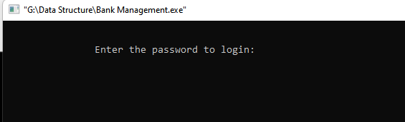

First of all we should login with password

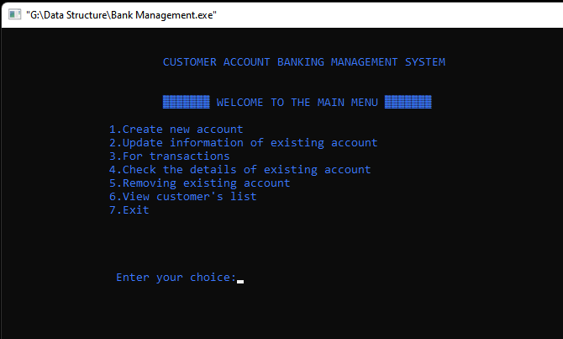

Where you want to go you should choice any number

Like you want to create new account so I input 1

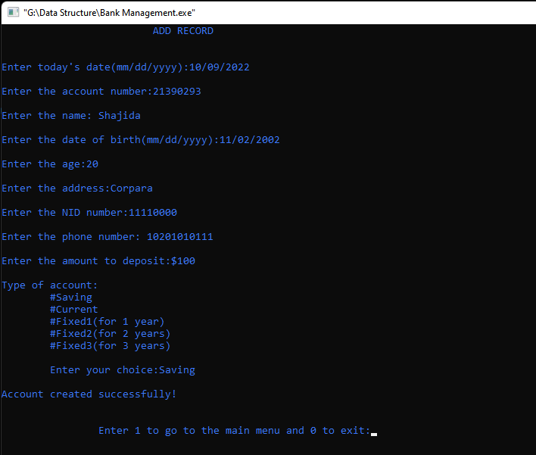

Step by Step give all information then save. If choice 1 then go to main menu if choice 0 then exit program.

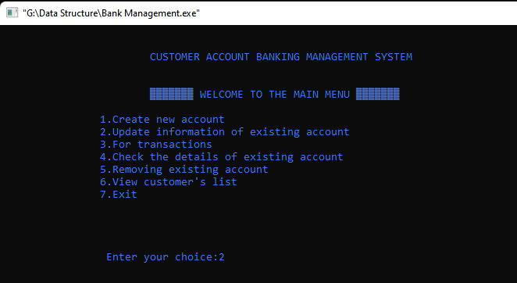

Choice 2 for update an information who open account in your bank.

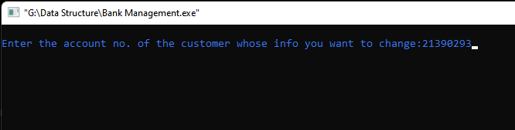

Search account by customer number

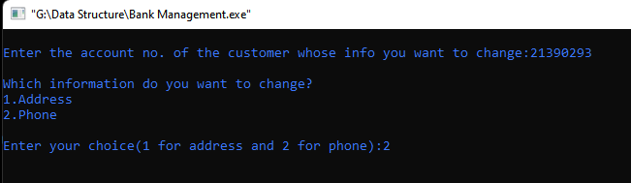

Enter your choice which you want to update like wants 2 so that inter 2

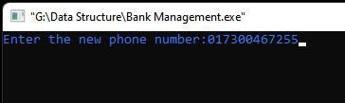

Give update number so enter update number

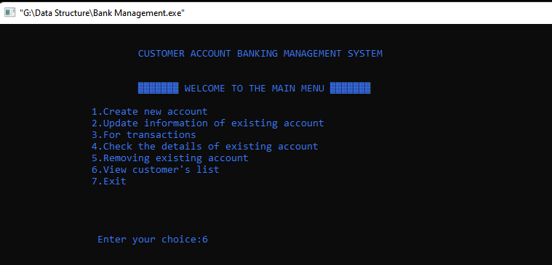

Choice 6 for see customer list.

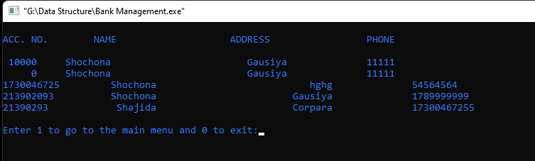

That is list who open account in your bank

# Chapter 4

**Conclusion**

**3.1 Introduction**

Many of us lead busy lives. Some of us are up before the crack of dawn, getting ourselves prepared so we can in turn get our families ready for the day. We rush to work, rush to get the kids to school, and at the end of the day we rush home only brace ourselves for the next day. After a hectic day, the last thing you want to do is spend time waiting in line at the bank, or even the post office. That's where Online Banking comes in. Many of the benefits of doing our banking online are obvious:

o You don't have to wait in line.

o You don't have to plan your day around the bank's hours.

o You can look at your balance whenever you want, not just when you get a statement.

**3.2 Practical Implications**

Online banking is an innovative tool that is fast becoming a

necessity. It is a successful strategic weapon for banks to remain profitable in a volatile and competitive marketplace of today. If proper training should be given to customer by the bank employs to open an account will be beneficial secondly the website should be made friendlier from where the first time customers can directly make and access their accounts.

Thus the Bank Management System it is developed and executed successfully

**3.3 Scope of Future Work**

The most valuable future looks are following below:

✓= More branches of the bank, maybe it will be international, that means more

ATM machines outside.

✓ = Customer issues development based on their needs, so the help desk will be aware of their needs and easy to use.

✓ = Developing a mobile App for banking system that help users to do the obtained his operations without go to the bank only he need to sign in using his A/C NO.

= password and then use your own PIN.

Finally the system will update automatically